EX.NO.1.1-DESIGN AND DRAFT THE

GIVEN 2D SKETCHES

IN MODELING SOFTWARE.

AIM
To sketch the given drawing with dimensions using a fusion 360 tool.

REQUIREMENTS

⏺ Computer or Laptop
⏺ Autodesk fusion
⏺ Mouse and keyboard
⏺ Windows 10

PROCEDURE

➡ Open Autodesk Fusion 360 and click Create Sketch.
➡Draw the top circles of Ø32 mm and Ø20 mm.
➡Draw the centre shape of Ø40 mm with R6 mm curves.
➡Draw the upper side curves using R64 mm.
➡Draw the outer body using the given R20 mm, R10 mm and R7 mm curves.
➡Draw the two side holes of Ø20 mm.
➡Draw the bottom circles of Ø20 mm and Ø10 mm.
➡Set the horizontal distances to 47 mm on both sides.
➡Set the vertical dimensions to 65 mm, 26 mm and 24 mm.
➡Use the Mirror tool to copy the shape to the other side.
➡Use the Trim tool to remove unwanted lines.
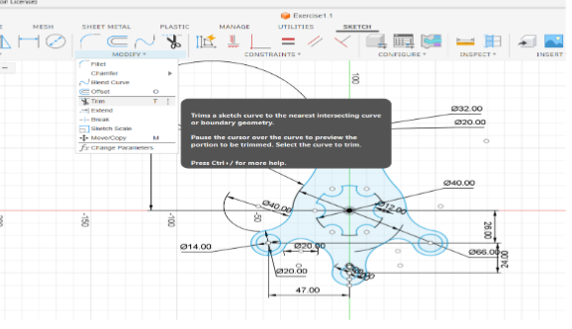
➡ Check the dimensions and close the sketch.
➡ Save the completed sketch.
➡Save the design and select Extrude.
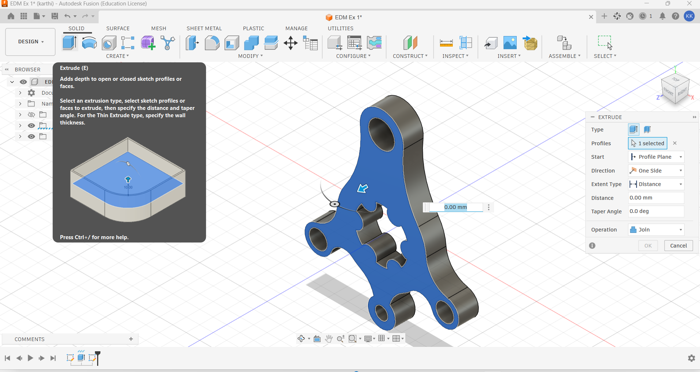
➡Select the sketch and give an extrusion distance of 15 mm.
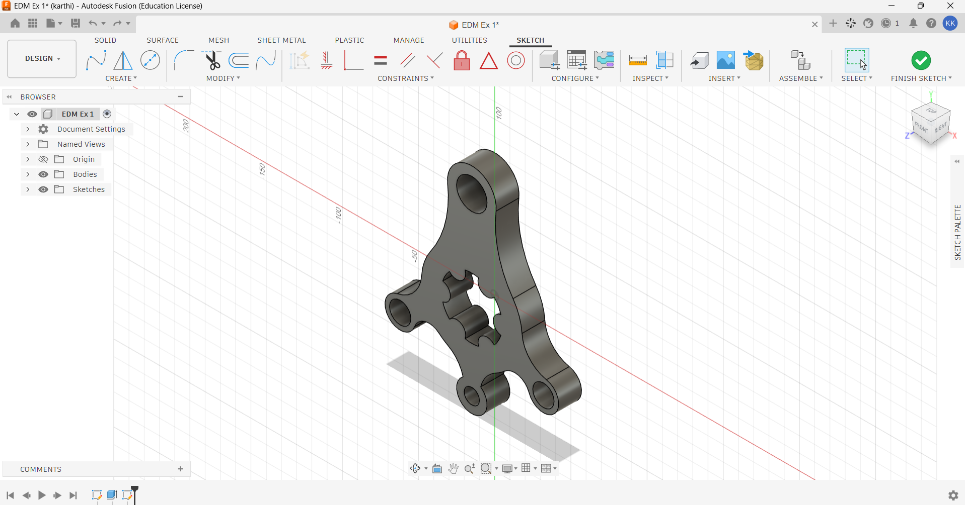
➡Finally, save the completed model.

SKETCHES

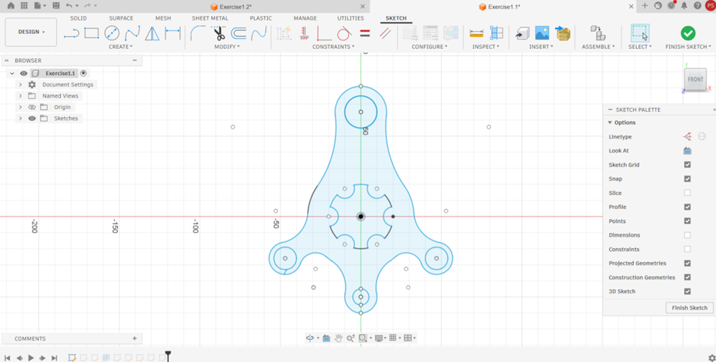

OUTPUT
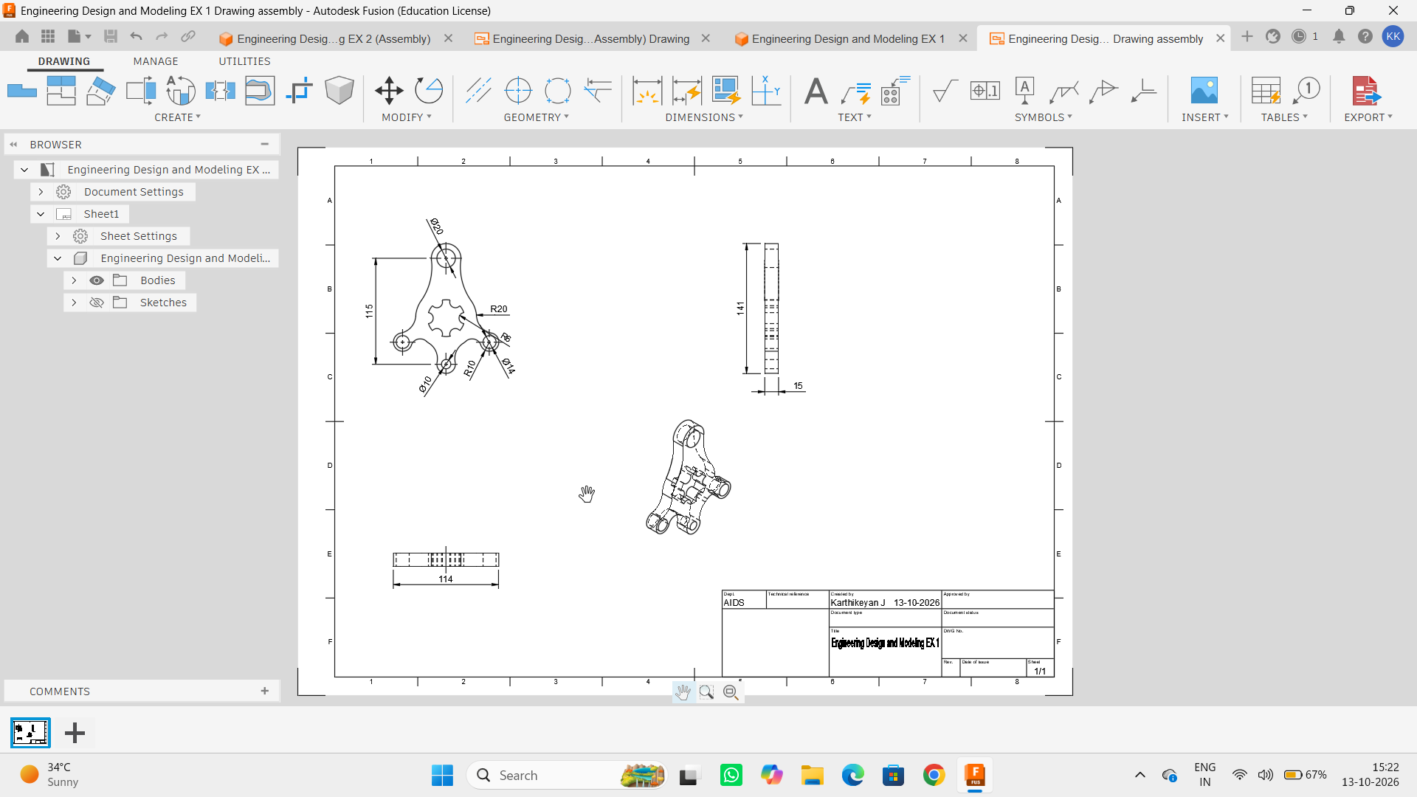

RESULT
Thus, the given sketch is drawn and drafted using fusion 360 tool.

